CONFERENCE POLICIES

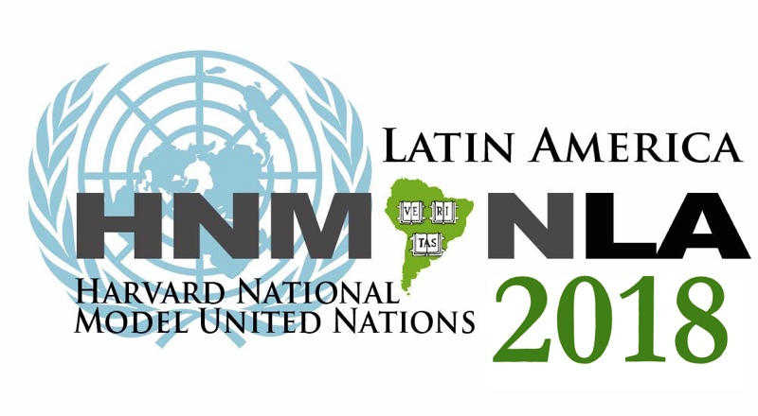

(The Conference Policies can be found and accepted at www.hnmunla.org when you submit an online application)

The Head Delegate or Faculty Advisor of each participating school should read these policies in their entirety. Your signature will indicate acceptance of all policies outlined on this form. Delegates are also expected to abide by all municipal and national laws while at HNMUN-LA.

GENERAL POLICIES

The Secretary-General, the Director-General, and the USG-Administration of the conference are the only staff members empowered to grant exceptions to any conference policies or other general HNMUN-LA practices. HNMUN-LA is not liable for any erroneous statements made by other staff members regarding exceptions to fees or policies.

All fees are owed to HNMUN-LA by 11:59PM EST on the dates outlined below. Schools will not be allowed to register at the conference until they have paid any outstanding debts to HNMUN-LA. If a school withdraws from the conference, the school is liable for all fees charged up to the date of withdrawal. Schools will only be assigned countries if all fees have been paid. If a school withdraws within 2 weeks after payment, they will receive a refund in full. If a school withdraws within 1 month after payment, they will receive a refund of half the payment. After 2 months, delegations and individual delegates will be considered for refund only on a case-by-case basis.

Please clearly label all forms and checks sent to the HNMUN-LA office. All checks should make out to “Harvard National Model United Nations - Latin America.” Checks should note in the Memo field the exact fees that are being paid (e.g. “School Name - 15 delegate fees”). Please note that our mail often takes 3-4 days longer than normal mail as it is processed through the Harvard University mail system, so mail any forms or checks well in advance of the final deadlines. Please note that PayPal, through MyMUN, is the preferred payment method.

REGISTRATION AND FEES

Registration for HNMUN-LA mainly occurs electronically through our MyMUN online platform, in a process that is outlined in the How to Apply section of our website. Similarly, fee payments are strongly preferred electronically via PayPal (for more information, visit hmunla.org/apply). If delegations wish to use alternative methods to electronic registration and payment, please contact us at info@hnmunla.org.

HNMUN-LA will have two priority registration deadlines and a final registration deadline. Those delegations who are accepted and make their full payment by 1 July, 2017 will qualify for Priority Registration I. These applicants will be prioritized in their country and committee preferences. Those delegations who are accepted and make their full payment by 1 September 2017 will qualify for Priority Registration II. These delegations will be prioritized in the second round of country assignments. The final deadline for registration is 15 November 2017.

After 15 November 2017, it will be possible to register with a late-fee. There will be a Registration Fee and Delegate Fee & Faculty Advisor Fee increase of US$15 and US$20, respectively, until 10 December 2017. After 10 December 2017, a last-minute fee of US$10 per participant will be added to the late-fee total for each week or part thereof that these fees have not been paid. Additionally, if delegate names and liability waivers are not submitted by 10 December 2017, a late fee of US$15 will be incurred.

Upon registration on MyMUN, each delegation or individual delegate must pay a Registration Fee of US$50 for administration expenses. This fee is independent of the number of delegates and faculty advisors in the delegation. Without the payment of this fee, the registration will be considered incomplete. Registration Fees are not refundable. All members of each delegation and individual delegates must pay an US$80 Delegate Fee. All faculty advisors must also pay an US$80 Faculty Advisor Fee.

No school can be assigned a country or any delegate roles until all fees have been paid. The Secretariat retains final authority over whether a delegation can be granted an exception that would temporarily postpone payment of the registration fee until after a position has been assigned. Upon submission of these payments, the school must confirm the number of delegates attending and their names.

Each delegation is required to have either a head delegate or a faculty advisor. The head delegate and faculty advisor will serve as the primary liaison between delegations and the HNMUN-LA staffers and are responsible for communicating administrative updates. Furthermore, these members will attend the Head Delegate & Faculty Advisor Meetings throughout conference to provide feedback for the conference. This does not apply to single delegates.

COUNTRY ASSIGNMENTS

The first round of country assignments will take place after the closure of the priority registration deadline on 1 July 2017. The next round of country assignments will take place on 1 September 2017, and the final round of country assignment will take place after the closure of the final registration deadline on 15 November 2017.

All decisions of the HNMUN-LA Secretariat with regard to country assignments are final. Schools should pay close attention to the minimum and maximum number of delegates for each country. Schools will not be assigned any countries whose minimum delegate spots exceed the number of delegates in each delegation at the time of application, and the Secretariat will do everything possible to assign delegations to countries that have a maximum that is the same as their delegation size. Schools can also be assigned to countries by organs only. In such cases, delegates representing the same country on different organs and from different schools do not need to confer when representing national policies.

The HNMUN-LA Secretariat reserves the right to remove spots from an already assigned country after 15 December 2017 in the event that the delegation fails to fill all the assigned spots. Delegations are required to assign at least one delegate to all assigned committees. This is extremely important to ensure that all country perspectives are represented in each committee.

SPECIAL CIRCUMSTANCES

If meeting the requirements for payment is impossible for any reason, please contact HNMUN-LA staff at info@hnmunla.org as soon as it becomes evident that the requirements will not be fulfilled. The Secretary-General, the Director-General, and the USG-Administration are more than happy to discuss individual circumstances with a school.

Delegates requiring special assistance, such as those mandated by the Americans with Disabilities Act (ADA) or the Peruvian Constitution, must notify HNMUN-LA by 10 December 2017.

CHANGES AND REFUNDS

The names of the delegates - given that the numbers are changed according to the above criteria - can be changed without penalty until 15 December 2017. After 10 December 2017, a US $10 fee will be charged to replace printed materials for each delegate. After 10 December 2017, no refunds on delegate or faculty advisor fees will be given.

FINANCIAL ASSISTANCE

The HNMUN-LA conference offers limited financial assistance to those who would otherwise be unable to attend the conference due to limited school funding or personal constraints. The application for financial assistance can be found on our website. Delegations are highly encouraged to apply for financial assistance by our priority deadline (1 August 2017). Financial assistance applications submitted after the priority deadline will be assessed on a first-come, first-served basis. Financial assistance applications submitted after our final submission deadline (15 November 2017) will not be accepted. Decisions will be announced in early December. Please contact the Under-Secretary-General of Finance at finance@hnmunla.org for more information about the financial assistance program or to discuss other fundraising options.

Financial assistance will be distributed only upon the completion of all committee sessions at conference, conditional upon all delegates of the delegation being in attendance at every session for its entire duration. The committee staff are the only individuals authorized to determine attendance and exceptions. Detailed receipts of the expenses for the conference are required. The Secretary-General and Director-General have the discretion of determining what expenses qualify for reimbursement and of refusing to reimburse delegates if the above conditions are not met.

MISCELLANEOUS FEES

Replacement badges may be purchased at the conference for a fee of US$5. Replacement placards may be purchased at the conference for a fee of US$5. Lost or misplaced conference handbooks may be purchased at the conference for a fee of US$5. HNMUN-LA will have certificates of participation available to all delegates that requested them on their application free of charge at conference. If certificates of participation are not picked up during the conference, certificates can be requested and mailed for a fee of US$5 each.

CANCELLATION DUE TO WEATHER CONDITIONS

HNMUN-LA 2018 will take place from 11-14 January 2018 regardless of the weather conditions. HNMUN-LA 2018 is unable to provide refunds to delegations that choose not to attend due to inclement weather.

SUSPENSION POLICY

While we realize that HNMUN-LA is a social as well as an academic forum, we must enforce certain security measures so that a professional atmosphere can be maintained at all times. In order to maintain order and safety at the conference as well as continuing a close relationship with the host team and the conference venue, our policy requires that any school whose delegates violate the following rules will be subject to at least a one-year suspension from the HNMUN-LA conference.

The suspension policy is not intended to threaten students, but rather to serve as a reminder to everyone that our primary goal at HNMUN-LA 2018 is to provide all participants with a meaningful academic and social experience. The following rules are a combination of Peruvian federal law and requirements of common courtesy and respect. Please have all delegates read these rules carefully. Observing them is the collective responsibility of the entire delegation.

HNMUN-LA AND THE CONFERENCE VENUE

HNMUN-LA 2018 will take place in Lima, Peru. Please note that delegates must provide their own travel and lodging accommodations.

ALCOHOL AND DRUG POLICY

Only those delegates age 18 or older may consume alcohol in Peru. Open containers of alcohol may not be carried in public areas, including committee rooms and hallways. Furthermore, delegates found possessing or using illicit drugs, as defined by Peruvian law, will be required to leave immediately and may be held criminally liable.

SMOKING POLICY

The City of Lima prohibits smoking indoors in public spaces. Delegates will not be permitted to smoke inside the conference venue.

VALUABLES

If delegates bring valuables, they are encouraged to place them in a hotel safe deposit box. HNMUN-LA, the conference venue, and organizers are not responsible for belongings left in guest rooms or in committee rooms.

COMMITTEE SESSION POLICY

All delegates are expected to be in their respective committee rooms during committee sessions. In order for delegates to leave their committee rooms for an extended period of time, both their Director and their Head Delegate/Faculty Advisor must be informed ahead of time. Furthermore, all delegates are expected to abide by committee dress code.

OTHER RULES

The Secretariat reserves the right to immediately expel delegates from both the conference and the venue due to unlawful and/or unacceptable behavior. Serious infractions on the part of even a single delegate may require the dismissal without refund of the individual involved and his/her delegation from the conference. If a delegate is dismissed from the conference, their delegation is automatically disqualified from conference awards.

The Secretariat reserves the right to define appropriate conference behavior and is particularly sensitive to issues involving displays of disrespect to other delegates, conference staff, and hotel staff.

The goal of the Secretariat and staff of HNMUN-LA 2018 is to work with you to achieve the most well-run, enjoyable, and productive conference possible. We thank you in advance for your cooperation, and please do not hesitate to email us at info@hnmunla.org with any questions or concerns.

By signing this form, you are confirming that you have read the HNMUN-LA 2018 Conference Policies and accept these conditions.

Please note that if you are registering through the online system at hnmunla.org, you are not required to submit a signed copy of this form.

_________________________________ _________________________________ _________________________________

Signature Name Date

HARVARD NATIONAL MODEL UNITED NATIONS – LATIN AMERICA 2018

